Q.1 a) List relevant technologies for distributed computing that provide concrete implementations of interaction models which are mainly based on message based communication.

Total :- 2M

1. Remote Procedure Call

2. Distributed Object Frameworks

1. Service-oriented Computing

Q.1 B) Draw and explain the web services technologies stack that lists all the components of the conceptual framework describing and enabling the web services abstraction.

Diagram: - 2 Mark

Explanation: - 3 Mark (5M)

The implementation of web services generally depends on technologies that are often organized in a layered stack. Examining the web service protocol stack is considered as the second option for viewing the web service architecture. In simple words, it is the set of protocols that are used to explore and execute web services. Currently, the web service protocol stack has four layers as given below:

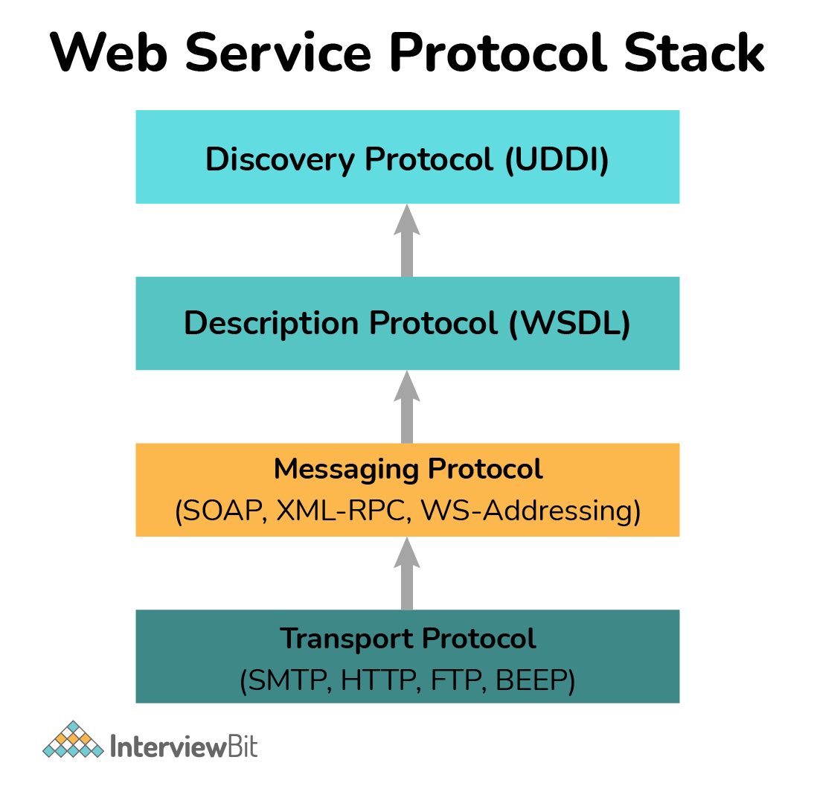

**Service Transport**: It is generally responsible to transport messages between applications. It basically defines technology standards for communication and allows messages or information to move across the network without any difficulty. It uses HTTP, SMTP, FTP, and DEEP protocols to transfer information.    
**XML Messaging**: It is generally responsible to encode messages into XML format so that one can understand these messages at either end. This layer generally includes XML-RPC and SOAP.    
**Service Description**: It is generally responsible to describe the public interface to a specific web service. WSDL is generally used to handle service descriptions.  
**Service Discovery**: It is generally responsible to centralize service into a common registry and provides easy functionality for publishing or finding web services. UDDI is generally used to handle service discovery.

Q 1. C) What is distributed memory MIMD architecture? List advantages of the same

Definition: 1.5 M

Advantages:- 1.5M (3M)

Distributed memory MIMD Architecture is known as Multicomputer. It can replicate the processor/memory pairs and link them through an interconnection network. The processor/memory pair is known as the processing element (PE) and PEs work more or less separated from each other.

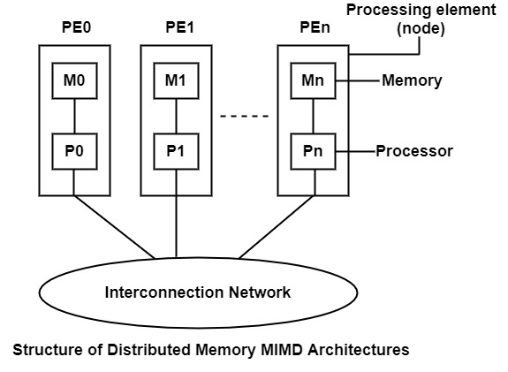

## Advantages of Distributed Memory MIMD Architectures

There are the following advantages of distributed memory MIMD architectures are as follows −

* Every processor has distributed memory system have their local memory, therefore, no problem of contention.
* The processor cannot connect through shared data structures and therefore sophisticated synchronization approaches like monitors are not required. Message passing solves all the requirements of communication and synchronization.
* These systems are highly scalable and good architecture candidates for building massively parallel computers.

Q.2 a) what are possible roles and tasks handled by cloud providers and consumers of Platform as a service?

For each role 1.5 M (3M)

Cloud consumers of PaaS can employ the tools and execution resources provided by cloud providers to develop, test, deploy and manage the applications hosted in a cloud environment. PaaS consumers can be application developers who design and implement application software, application testers who run and test applications in cloud-based environments, application deployers who publish applications into the cloud, and application administrators who configure and monitor application performance on a platform. PaaS consumers can be billed according to, processing, database storage and network resources consumed by the PaaS application, and the duration of the platform usage.

For PaaS, the Cloud Provider manages the computing infrastructure for the platform and runs the cloud software that provides the components of the platform, such as runtime software execution stack, databases, and other middleware components. The PaaS Cloud Provider typically also supports the development, deployment and management process of the PaaS Cloud Consumer by providing tools such as integrated development environments (IDEs), development version of cloud software, software development kits (SDKs), deployment and management tools. The PaaS Cloud Consumer has control over the applications and possibly some the hosting environment settings, but has no or limited access to the infrastructure underlying the platform such as network, servers, operating systems (OS), or storage

Q. 2B)

Differentiate between cluster, grid and cloud computing on the basis of following points.

For each comparison point:- 0.5 M (3M)

Basic Idea, Running processes, Location of nodes, virtualization, Interoperability, Resource management

|  |  |  |  |  |  |
| --- | --- | --- | --- | --- | --- |
| **Table 1 Summary of cluster, grid, and cloud computing paradigms Cluster Computing** | | **Grid Computing** | | **Cloud Computing** | |
| **Basic Idea** | Aggregation of resources. | | Segregation of Resources. | | Consolidation of Resources. |
| **Running Processes** | Same processes run on all computers over the cluster at the same time. | | Job is divided into sub-jobs each is assigned to an idle CPU so they all run concurrently. | | Depends on service provisioning. Which computer offers a service and provisions it to the requesting clients. |
| **Operating System** | All nodes must run the same operating system. | | No restriction is made on the operating system. | | No restriction is made on the operating system. |
| **Job Execution** | Execution depends on job scheduling. So, jobs wait unit it’s assigned a runtime. | | Execution is scalable in a way that moves the execution of a job to an idle processor (node). | | Self-Managed. |
| **Suitable for Apps** | Cascading tasks. If one tasks depends on another one. | | Not suitable for cascading tasks. | | On-demand service provisioning. |
| **Location of nodes** | Physically in the same location | | Distributed geographically all over the globe. | | Location doesn’t matter |
| **Homo/Heterogeneity** | Homogenous | | Heterogeneous | | Heterogeneous |
| **Virtualization** | None | | None | | Virtualization is a key |
| **Transparency** | Yes | | Yes | | Yes |
| **Security** | High | | High, but doesn’t reach the level of cluster computing. | | Lower than both types. |
| **Interoperability** | Yes | | Yes | | No |
| **Application Domains** | industrial sector, research centers, health care, and centers that offer services on the nation-wide level | | industrial sector, research centers, health care, and centers that offer services on the nation-wide level | | Banking, Insurance, Weather Forecasting, Space Exploration, Business, IaaS, PaaS, SaaS |
| **Implementation** | Easy | | Difficult | | Difficult – need to be done by the host. |
| **Management** | Easy | | Difficult | | Difficult |
| **Resource Management** | Centralized (locally) | | Distributed | | Both centralized and distributed. |
| **Internet** | No internet access is required | | Required | | Required |

--OR—

Differentiate between SOAP and REST Protocol.

|  |  |
| --- | --- |
| **SOAP** | **REST** |
| SOAP stands for Simple Object Access Protocol | REST stands for Representational State Transfer |
| SOAP is a protocol. SOAP was designed with a specification. It includes a WSDL file which has the required information on what the web service does in addition to the location of the web service. | REST is an Architectural style in which a web service can only be treated as a RESTful service if it follows the constraints of being   1. Client Server 2. Stateless 3. Cacheable 4. Layered System 5. Uniform Interface |
| SOAP cannot make use of REST since SOAP is a protocol and REST is an architectural pattern. | REST can make use of SOAP as the underlying protocol for web services, because in the end it is just an architectural pattern. |
| SOAP uses service interfaces to expose its functionality to client applications. In SOAP, the WSDL file provides the client with the necessary information which can be used to understand what services the web service can offer. | REST use Uniform Service locators to access to the components on the hardware device. For example, if there is an object which represents the data of an employee hosted on a URL as http://demo.guru99 , the below are some of URI that can exist to access them.  http://demo.guru99.com/Employee  http://demo.guru99.com/Employee/1 |
| SOAP requires more bandwidth for its usage. Since SOAP Messages contain a lot of information inside of it, the amount of data transfer using SOAP is generally a lot.  <?xml version="1.0"?>  <SOAP-ENV:Envelope  xmlns:SOAP-ENV  ="http://www.w3.org/2001/12/soap-envelope"  SOAP-ENV:encodingStyle  =" http://www.w3.org/2001/12/soap-encoding">  <soap:Body>  <Demo.guru99WebService  xmlns="http://tempuri.org/">  <EmployeeID>int</EmployeeID>  </Demo.guru99WebService>  </soap:Body>  </SOAP-ENV:Envelope> | REST does not need much bandwidth when requests are sent to the server. REST messages mostly just consist of JSON messages. Below is an example of a JSON message passed to a web server. You can see that the size of the message is comparatively smaller to SOAP.  {"city":"Mumbai","state":"Maharastra"} |
| SOAP can only work with XML format. As seen from SOAP messages, all data passed is in XML format. | REST permits different data format such as Plain text, HTML, XML, JSON, etc. But the most preferred format for transferring data is JSON. |

Q. 2C) Choosing between SaaS and the on-premises solution involves evaluating data before deciding about the software delivery method. Which questions will you ask that can help the user make the correct decision? Also compare saas vs. On–Premise solution on at least 5 points.

For questions :- 2.5 M, comparison:- 2.5 M ( 5M)

Choosing between SaaS and the on-premises solution involves evaluating data before deciding about the software delivery method. Here are a few points that can help the user make the correct decision:

* Do you have a specific requirement in mind aka business need?
* How much data (relevant) is within the scope of the project?
* Is the existing hardware good enough to deal with the current requirements?
* Are you able to scale the storage capacity according to growing business needs?
* What is the current cost of data, including hosting fees, IT infrastructure, maintenance, and other internal resources?
* How many users need the data and when aka touch-points?

SaaS is a better option if you are dealing with a huge amount of data and are using old hardware. Storage scalability is another reason that favors SaaS, while many businesses don’t have the human resources needed to make an on-premises solution a success. On the other hand, SaaS isn’t the best solution if security compliance of an enterprise does not allow 3rd party hosting, making on-premises solutions a better (or the only) option.

## SaaS vs. On-premises Comparison

### ****Cost****

The entry cost of both single and multitenant SaaS is fairly low compared to on-premises solutions. But the year-over-year cost of SaaS is high and businesses might end up spending more in the long run. SaaS pricing models are flexible, while upgrade costs are also pretty low. SaaS minimizes the costs related to internal resources and IT support as the provider is responsible for most things.

The entry and operations cost of on-premises solutions is high, but on-going maintenance costs are low. Businesses also need their own IT infrastructure and human resources to create a new environment and provide support. In-house solutions also come with higher up-gradation and maintenance costs.

### ****Implementation****

Both single and multitenant SaaS solutions can be implemented in less time compared to in-house solutions. That’s because users can get started right away after signing up for a subscription. SaaS solutions leverage the existing platform that the vendor has already implemented, provisioned and tested. On-premises solutions, on the other hand, take time, human resources and money, while they also have to be upgraded manually, whether software or hardware.

### ****Customization****

Customization of multitenant SaaS solutions is usually not possible as a large number of users have to share the same application instance. However, customization of single tenant SaaS is fairly easy if the app allows it. On-premises solutions offer more flexibility in this regard and allow enterprises to customize almost everything. Better customization also relates to more control over how the information is processed, stored and presented, which is not something most SaaS vendor provides details about.

### ****Maintenance and Support****

SaaS requires very little to no IT dependency for app maintenance and support, which is mostly limited to validation review and customization. Since the provider takes the responsibility to ensure availability, security and disaster recovery, businesses don’t have to worry about the IT stuff. However, businesses have to trust the service provider with processing valuable corporate data.

As far as on-premises solutions are concerned, enterprises themselves are responsible for everything, including deployment and maintenance of the software. The internal IT staff also has to ensure availability, but in return, businesses get complete control over their data and a much better sense of ownership.

### ****Scalability****

SaaS solutions can easily be scaled according to growing business needs, while they can also be scaled down to minimize wastage of resources. On-premises solutions require long-term planning for scaling and are often not the best solution for growing businesses as the IT staff has to constantly struggle in the upgrade loop.

### ****Upgrades****

On-premises upgrades are often costly and time-consuming, while the IT staff own the responsibility to plan, deploy and validate upgrades. SaaS upgrades are easier, iterative and require little involvement of the internal IT staff.

### ****Security and Regulatory Compliance****

On-premises solutions require additional time and resources for high-level security. High-end SaaS providers offer top-notch security and take care of supervision of the servers and network. The providers provide baseline validation for user review and enforcing regulatory requirements is fairly straight forward. In the case of on-premises solutions, the internal IT staff is responsible for validation and enforcement of the regulatory requirements. But since they have complete control over the environment, enforcing regulatory requirements is comparatively easier.

Q. 3A) WCE ACM Student Chapter is going to arrange a HACKATHON 2023 during 16-17th March 2023. Consider yourself as one of the techno-savvy members of the organizing team. How will you organize the event with the help of cloud computing event management applications? Which features of the applications will you use essentially for successful execution of the event?

For each feature :- 0.5M (5M)

* The more full-featured apps include management of everything from pre-event marketing to post-event analysis.
  + Event Planning and Workflow Management
    - ability not just to track individual tasks in a to-do list fashion, but also benefit from sophisticated workflow management.
    - you need to know which tasks need to be completed before later tasks can be started; you need to know who’s doing what, and be alerted to any tasks that are unstaffed or understaffed.
    - In other words, you need the planning and workflow management functionality to continue into the event itself, so that you can manage your staff in an efficient and effective manner.
* Event Marketing
  + event management applications include modules to help you market your event.
  + For example, many apps offer web-based email marketing, which lets you promote your event via targeted email messages.
  + Other apps help you create your own event website (on their cloud computers), which also helps to promote your event.
* Event Calendar
  + an online calendar that displays all the happenings within your overall event.
* Facilities Scheduling
  + this module ties into the event host’s systems, giving you complete power over room or hall scheduling.
* Advance Registration
  + most event management apps include a web-based registration module, where attendees can sign up (and, in most cases, pay) for the event. Attendee information is entered into a web form, and that data is then stored on the application provider’s cloud servers.
* Payment Processing
  + Collecting payment for your advance and onsite registrants is a key part of the event management experience.
* Travel Management
  + If you’re running a real “hands-on” event, you might want to consider offering travel services to select attendees.
* Housing Management
  + More common is a housing management module that helps match event attendees with available rooms at your event hotel.
* Onsite Registration
  + Your attendees sign up (and probably pay) for your event in advance. But when they arrive on opening day, you need to sign them in, print out badges, provide a welcoming packet, and so forth.

Q. 3B) What is "EUCALYPTUS" in cloud computing? Why is it used?

Definition : 1M

Usage:- 1M (2M)

* EUCALYPTUS” stands for Elastic Utility Computing Architecture For Linking Your Programs To Useful Systems”
* “Eucalyptus” is an open source software infrastructure in cloud computing, which is used to implement clusters in cloud computing platform. It is used to build public, hybrid and private clouds. It has the ability to produce your own data center into a private cloud and allows you to use its functionality to many other organizations.

Q 3C) What are advantages of cloud computing?

For each point :- 0.5 M (2M)

* Lower computer costs:
* Improved performance:
* Reduced software costs:
* Instant software updates
* Improved document format compatibility.
* Easier group collaboration

Q. 3C) List essential characteristics of cloud computing? (2M)

* On-demand self-service

A consumer can unilaterally provision computing capabilities, such as server time and network storage, as needed automatically without requiring human interaction with each service provider.

* Broad network access

Capabilities are available over the network and accessed through standard mechanisms that promote use by heterogeneous thin or thick client platforms (e.g., mobile phones, tablets, laptops, and workstations).

* Resource pooling

The provider’s computing resources are pooled to serve multiple consumers using a multi-tenant model, with different physical and virtual resources dynamically assigned and reassigned according to consumer demand.

* Measured Service

Cloud systems automatically control and optimize resource use by leveraging a metering capability at some level of abstraction appropriate to the type of service (e.g., storage, processing, bandwidth, and active user accounts). Resource usage can be

monitored, controlled, and reported, providing transparency for both the provider and consumer of the utilized service.

* Rapid elasticity

Capabilities can be elastically provisioned and released, in some cases automatically, to scale rapidly outward and inward commensurate with demand. To the consumer, the capabilities available for provisioning often appear to be unlimited and can be appropriated in any quantity at any time.